

**PROJECT REPORT**

**On**

**MEDICAL BILLING SYSTEM**

*Submitted in partial fulfillment of* DBMS Laboratory With Mini-Project (15CSL58)

**Fifth Semester of the Degree of Bachelor of Engineering**

in

**COMPUTER SCIENCE AND ENGINEERING of**

**Visvesvaraya Technological University (VTU), Belgaum**

**during the year 2017-18**



**Carried out by**

**Subham Agarwal**

**1SB15CS083**

**Saurabh Kumar**

**1SB15CS070**

Under the Guidance

of

**Mrs. P.KALAMANI**

Assistant Professor

Dept. of Computer Science Engineering,

Sri Sairam College of Engineering, Bangalore

**Department of Computer Science and Engineering**

**SRI SAIRAM COLLEGE OF ENGINEERING**

**Anekal, Bangalore - 562106**



1 | P a g e

**SRI SAIRAM COLLEGE OF ENGINEERING**

**Anekal, Bangalore - 562106**



**Department of Computer Science and Engineering**

**CERTIFICATE**

Certified that project work entitled “**MEDICAL BILLING SYSTEM**” is bonafide work carried out by

**Subham Agarwal**

**(1SB15CS083)**

**Saurabh Kumar**

**(1SB15CS070)**

In partial fulfillment for the award of the Bachelor of Engineering in Computer Science and Engineering Of the Viseveswaraya Technological University, Belgaum during the year 2017-18. It is certified that all corrections/suggestions indicated for the internal assessment have been incorporated in the report deposited in the department library. The project has been approved as it satisfies the academic requirements in respect of the project work prescribed for Bachelor of Engineering Degree.

|  |  |  |
| --- | --- | --- |
| Signature of the Guide | Signature of the HOD | Signature of the Principal |
| Mrs. P.Kalamani | Dr. B. Shadaksharappa | Dr. Y. Vijayakumar |
| Asst. Prof., CSE Dept. | HOD, CSE Dept., | Principal, |
| SSCE. | SSCE. | SSCE. |
| External Viva |  |  |

Name of the Examiners: 1.____________________________

2.___________________________



2 | P a g e



**DECLARATION**

We, the students of the fifth semester of Computer Science and Engineering, Sri Sairam College of Engineering, Anekal, declare that the work entitled **“MEDICAL BILLING SYSTEM”** has been successfully completed under the guidance of **Mrs. P. Kalamani**, Assistant Professor Computer Science and Engineering Department, Sri Sairam College of Engineering, Anekal. This dissertation work is submitted to Visvesvaraya Technological University in partial fulfillment of the requirements for the award of Degree of Bachelor of Engineering in Computer Science during the academic year 2017 - 2018. Further, the matter embodied in the project report has not been submitted previously by anyone for the award of any degree or diploma to any university.

Place:

Date:

|  |  |  |
| --- | --- | --- |
| Team members: | |  |
| 1. | Subham Agarwal | (1SB15CS083) |
| 2. | Saurabh Kumar | (1SB15CS070) |



3 | P a g e



**ACKNOWLEDGEMENT**

The knowledge and satisfaction that accompanies a successful completion of a project is hard to describe. Behind any successful project there are wise people guiding throughout. We thank them for guiding us, correcting our mistakes, and providing valuable feedback. We would consider it as our privilege to express our gratitude and respect to all those who guided and encouraged us in this project.

We extend our heartfelt gratitude to our chairman, **MJF.LN.LEO** **MUTHU** and also to our beloved principal, **DR. Y. VIJAYA KUMAR** for the success of this project.

We are grateful to **Dr. B. SHADAKSHARAPPA**, Head of CSE Department and Vice Principal, Sri Sairam College Of Engineering, for providing support an encouragement.

We convey our sincerest regards to our Lab guide, **Mrs. P.** **KALAMANI ,** Asst. Prof., Dept. of CSE, SSCE, for providingguidance and encouragement at all times needed.



4 | P a g e



**ABSTRACT**

**Medical billing system projects** main idea is toimplement a software application for medical shops and hospitals for maintaining easy billing system. Data is maintained in database, mySQL is used as database in this project. In existing system medical transactions and patients information is maintained in the form of manual records. In this process data is not accurate there are chances of losing data and retrieving old records is not possible. In existing system entire data is maintained in the form of database and cost for maintaining records is easy.



5 | P a g e



**CONTENTS**

|  |  |  |
| --- | --- | --- |
| **SL NO** | **TITLE** | **PG NO** |
| **1.** | **Introduction** | **7** |
| **2.** | **System Requirements** | **9** |
|  | 2.1 Hardware Requirements | 9 |
|  | 2.2 Software Requirements | 9 |
| **3.** | **Schema Diagram** | **10** |
| **4.** | **E-R Diagram** | **11** |
| **5.** | **Implementation** | **12** |
| **6.** | **Snapshots** | **34** |
| **7.** | **Conclusion** | **37** |
| **8.** | **Bibliography** | **38** |



6 | P a g e



1. **INTRODUCTION**

This project is very popular and widely used in many organizations for generating various types of bills to their customer. This is an stand-alone system and is used to maintain most of the activities happening in organizations. This project is aimed at developing a system by which the employees in the organization can generate the bills to their customers. The bill will pass through a workflow process and the owner of the bill or bill creator can view the status of the bill at any time.The main purpose of this project is aimed at developing a system which reduces work burden of employees of the organization. Every Organization has some maintenance and budget planning’s. In this situation generating the bills to their customers will be a headache and we have to maintain records manually. Some times in manual process there is a possibility to get errors. To overcome these difficulties and time being best to use this type of application. In this the employees in the organization generate the bills to their customers. The bills could be of various types and also of various amounts. The bill will pass through a workflow process and the owner of the bill can view the status of the bill at any time.The project has been planned to be having the view of distributed architecture, with centralized storage of the database. The application for the storage of the data has been planned. Using the constructs of MS-SQL Server and all the user interfaces have been designed using the C#.Net technologies. The database connectivity is planned using the “SQL Connection” methodology. The standards of security and data protective mechanism have been given a big choice for proper usage. The application takes care of different modules and their associated reports, which are produced as per the applicable strategies and standards that are put forwarded by the administrative staff.

The entire project has been developed keeping in view of the distributed client server computing technology, in mind. The specification has been normalized up to 3NF to eliminate all the anomalies that may arise due to the database transaction that are executed by the general users and the organizational administration. The user interfaces are browser specific to give distributed accessibility for the overall system. The internal database has been selected as MS-SQL server .The basic constructs of table spaces, clusters and indexes have been exploited to provide higher consistency and reliability for the data storage. The MS-SQL server was a choice as it provides the constructs of high-level reliability and security. The total front end was dominated using the C#.Net technologies. At all proper levels high care was taken to check that the system manages the data consistency with proper business rules or validations. The database connectivity was planned using the latest “SQL



7 | P a g e



Connection” technology provided by Microsoft Corporation. The authentication and authorization was crosschecked at all the relevant stages. The user level accessibility has been restricted into two zones namely. Problems in the existing system :-

* It is limited to a single system.
* It is less user-friendly.
* It is having lots of manual work (Manual system does not mean that you are working with pen and paper, it also include working on spread sheets and other simple software's)
* It requires more no of employees need to work.
* It is time consuming process.
* The present system is very less secure.
* It is unable to generate different kinds of report.

Solution of these Problems :-

The development of the new system contains the following activities, which try to automate the entire process keeping in view of the database integration approach.

* User friendliness is provided in the application with various controls.
* The system makes the overall project management much easier and flexible.
* Various classes have been used to provide file upload and mail features.
* There is no risk of data mismanagement at any level while the project development is under process.



8 | P a g e



1. **SYSTEM REQUIREMENTS**

**2.1 HARDWARE REQUIREMENTS**

* PIV 2.8 GHz Processor and Above
* RAM 512MB and Above
* HDD 20 GB Hard Disk Space and Above

**2.2 SOFTWARE REQUIREMENTS**

* WINDOWS OS (XP / 2000 / 200 Server / 2003 Server/ 2007/ 8/ 10)
* Visual Studio .Net 2005 Enterprise Edition
* Internet Information Server 5.0 (IIS)
* Visual Studio .Net Framework (Minimal for Deployment)
* SQL Server 2000 Enterprise Edition



9 | P a g e



1. **SCHEMA DIAGRAM**

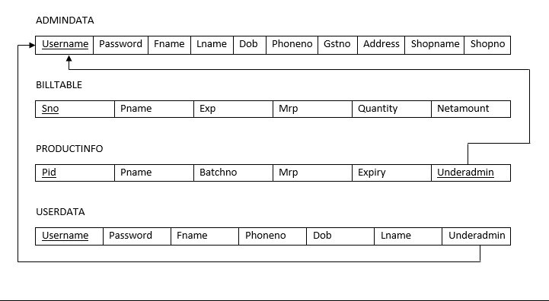

10 | P a g e



1. **E-R DIAGRAM**

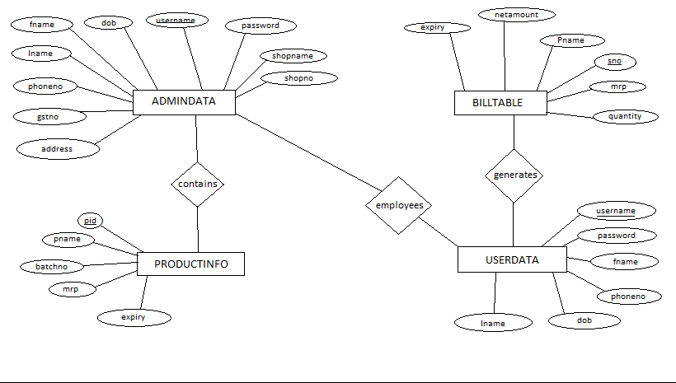

11 | P a g e



1. **IMPLEMENTATION**

**BillingPage.xaml.cs**

using System;

using System.Collections.Generic;

using System.Linq;

using System.Text;

using System.Threading.Tasks;

using System.Windows;

using System.Windows.Controls;

using System.Windows.Data;

using System.Windows.Documents;

using System.Windows.Input;

using System.Windows.Media;

using System.Windows.Media.Imaging; using System.Windows.Shapes; using System.Data.SqlClient; using System.Data;

namespace Billing

{

* <summary>
* Interaction logic for BillingPage.xaml
* </summary>

public partial class BillingPage : Window {

int count = 1;

public static string underAdmin1; public BillingPage(string underAdmin) {

InitializeComponent();

SqlConnection con = new SqlConnection(@"Data Source=(LocalDB)\v11.0;AttachDbFilename=C:\Databases\Billing.mdf;Int egrated Security=True;Connect Timeout=30");

con.Open();



12 | P a g e

string ShopName,adminName,shopNo,Address; adminName = underAdmin; underAdmin1 = underAdmin;

SqlDataReader dr1,dr;

SqlCommand cm = new SqlCommand("select ShopName,Address,ShopNo from AdminData where username='"+underAdmin+"' ", con);

dr1 = cm.ExecuteReader();

while(dr1.Read())

{

lblShopNoAddress.Content = dr1["ShopNo"].ToString() + "," + dr1["Address"].ToString();

lblShopNameAddItem.Content=dr1["ShopName"].ToString();

}

dr1.Close();

try

{

SqlCommand cmd6 = new SqlCommand("delete from BillTable",

con);

cmd6.ExecuteNonQuery();

if (comboItemsAdd.Items.Count>0)

comboItemsAdd.Items.Clear();

SqlCommand cmd = new SqlCommand("select pname from productinfo where underAdmin='"+underAdmin1+"'", con);

dr=cmd.ExecuteReader();

while(dr.Read())

{

comboItemsAdd.Items.Add(dr[0].ToString());

}

dr.Close();

con.Close();

}

catch (Exception e)

{

MessageBox.Show(e.ToString());

}

}

public static int d1, d2;



13 | P a g e

private void Button_Click(object sender, RoutedEventArgs e) {

int netamount;

lblCustomerName.Content = txtBoxCustomerName.Text; lblShopInfo.Content = lblShopNameAddItem.Content + "," +

lblShopNoAddress.Content;

lblDate.Content = System.DateTime.Now.ToString();

SqlDataReader dr;

SqlConnection con = new SqlConnection(@"Data Source=(LocalDB)\v11.0;AttachDbFilename=C:\Databases\Billing.mdf;Int egrated Security=True;Connect Timeout=30");

con.Open();

SqlCommand cmd = new SqlCommand("select mrp from productinfo where pname='"+comboItemsAdd.Text+"' and underAdmin='"+underAdmin1+"'", con);

dr = cmd.ExecuteReader();

while (dr.Read())

{

d1 =(dr.GetInt32(0));

}

dr.Close();

con.Close();

SqlConnection con1 = new SqlConnection(@"Data Source=(LocalDB)\v11.0;AttachDbFilename=C:\Databases\Billing.mdf;Int egrated Security=True;Connect Timeout=30");

con1.Open();

SqlCommand cmd1 = new SqlCommand("select expiryDate from productinfo where pname='" + comboItemsAdd.Text + "' and underAdmin='"+underAdmin1+"'", con1);

dr = cmd1.ExecuteReader();

while (dr.Read())

{

lbl1.Text=(dr["expiryDate"].ToString());

}

con1.Close();

dr.Close();



14 | P a g e



SqlConnection con2 = new SqlConnection(@"Data Source=(LocalDB)\v11.0;AttachDbFilename=C:\Databases\Billing.mdf;Int egrated Security=True;Connect Timeout=30");

con2.Open();

SqlCommand cmd3 = new SqlCommand("billAdd",con2); cmd3.CommandType = CommandType.StoredProcedure; netamount = d1 * int.Parse(txtBoxQuantity.Text); cmd3.Parameters.AddWithValue("@SNO",count.ToString()); cmd3.Parameters.AddWithValue("@PNAME",comboItemsAdd.Text); cmd3.Parameters.AddWithValue("@EXP",lbl1.Text); cmd3.Parameters.AddWithValue("@MRP",d1); cmd3.Parameters.AddWithValue("@QUANTITY",

txtBoxQuantity.Text);

cmd3.Parameters.AddWithValue("@NETAMOUNT", netamount);

cmd3.ExecuteNonQuery();

count++;

try

{

con.Open();

string query = "select * from BillTable"; SqlCommand cmd4 = new SqlCommand(query, con); //cmd4.ExecuteNonQuery();

SqlDataAdapter da = new SqlDataAdapter(cmd4); DataTable dt = new DataTable(BillTable); da.Fill(dt);

dataGrid.ItemsSource = dt.DefaultView;

da.Update(dt);

con.Close();

}

catch(Exception ew)

{

MessageBox.Show(ew.Message);

}

MessageBox.Show("ITEMS ADDED");

con2.Close();

}



15 | P a g e

public string BillTable { get; set; }

private void Button_Click3(object sender, RoutedEventArgs e) {

SqlConnection con = new SqlConnection(@"Data Source=(LocalDB)\v11.0;AttachDbFilename=C:\Databases\Billing.mdf;Int egrated Security=True;Connect Timeout=30");

con.Open();

SqlCommand cmd = new SqlCommand("SELECT sum(quantity*mrp) from BillTable", con);

SqlDataReader dr;

dr = cmd.ExecuteReader();

while(dr.Read())

{

string total = dr[0].ToString();

lblTotalAmount.Content = total;

}

}

private void btnBack_Click(object sender, RoutedEventArgs e)

{

this.Close();

MainWindow obj = new MainWindow(); obj.Show();

}

private void btnNew_Click(object sender, RoutedEventArgs e)

{

this.Close();

BillingPage obj = new BillingPage(underAdmin1); obj.Show();

}

}

}



16 | P a g e



**MainWindow.xaml.cs**

using System;

using System.Collections.Generic;

using System.Linq;

using System.Text;

using System.Threading.Tasks;

using System.Windows;

using System.Windows.Controls;

using System.Windows.Data;

using System.Windows.Documents;

using System.Windows.Input;

using System.Windows.Media;

using System.Windows.Media.Imaging; using System.Windows.Navigation; using System.Windows.Shapes;

namespace Billing

{

* <summary>
* Interaction logic for MainWindow.xaml
* </summary>

public partial class MainWindow : Window {

public MainWindow()

{

InitializeComponent();

}

private void Image_MouseLeftButtonDown(object sender, MouseButtonEventArgs e)

{

this.Hide();

winAdminLog obj = new winAdminLog(); obj.Show();

}

private void Image_MouseLeftButtonDown_1(object sender, MouseButtonEventArgs e)

{

this.Hide();

winUserLog obj = new winUserLog();



17 | P a g e

obj.Show();

}

private void ExitBtn_Click(object sender, RoutedEventArgs e)

{

this.Close();

}

}

}

**winAdminLog.xaml.cs**

using System;

using System.Data;

using System.Collections.Generic;

using System.Linq;

using System.Text;

using System.Threading.Tasks;

using System.Windows;

using System.Windows.Controls;

using System.Windows.Data;

using System.Windows.Documents;

using System.Windows.Input;

using System.Windows.Media;

using System.Windows.Media.Imaging; using System.Windows.Shapes; using System.Data.SqlClient; using System.Data.SqlClient;

namespace Billing

{

* <summary>
* Interaction logic for winAdminLog.xaml
* </summary>

public partial class winAdminLog : Window {

public winAdminLog()

{

InitializeComponent();

}

private void btn_ClickLog(object sender, RoutedEventArgs e)



18 | P a g e

{

SqlConnection con = new SqlConnection(@"Data Source=(LocalDB)\v11.0;AttachDbFilename=C:\Databases\Billing.mdf;Int egrated Security=True;Connect Timeout=30;");

con.Open();

SqlDataAdapter sda = new SqlDataAdapter("Select Count(*) from AdminData where username='" + txtBoxAdminUsername.Text + "' and password= '" + txtBoxAdminPass.Text + "'",con);

DataTable dt = new DataTable();

con.Close();

sda.Fill(dt);

if (dt.Rows[0][0].ToString() != "1") MessageBox.Show("Invalid Username or password");

if (dt.Rows[0][0].ToString() == "1")

{

this.Close();

winAdminReg obj = new

winAdminReg(txtBoxAdminUsername.Text);

obj.Show();

}

}

private void Label_MouseLeftButtonDown(object sender, MouseButtonEventArgs e)

{

this.Close();

winAdminRegNew obj = new winAdminRegNew(); obj.Show();

}

private void btnBack_Click(object sender, RoutedEventArgs e)

{

this.Close();

MainWindow obj = new MainWindow(); obj.Show();

}

}

}



19 | P a g e



**winAdminReg.xaml.cs**

using System;

using System.Collections.Generic;

using System.Linq;

using System.Text;

using System.Threading.Tasks;

using System.Windows;

using System.Windows.Controls;

using System.Windows.Data;

using System.Windows.Documents;

using System.Windows.Input;

using System.Windows.Media;

using System.Windows.Media.Imaging; using System.Windows.Shapes; using System.Data.SqlClient; using System.Data;

namespace Billing

{

* <summary>
* Interaction logic for winAdminReg.xaml
* </summary>

public partial class winAdminReg : Window {

public static string adminUsername; public winAdminReg(string adminSession) {

InitializeComponent(); lblAdminSession.Content = adminSession; adminUsername = adminSession;

}

private void btnUserAddSubmit_Click(object sender, RoutedEventArgs

e)

{

if(txtBoxUserpass1.Text != txtBoxUserpass2.Text)

{

MessageBox.Show("Re-Enter the password"); txtBoxUserpass1.Text = txtBoxUserpass2.Text = "";

}



20 | P a g e

else

{

SqlConnection con = new SqlConnection(@"Data Source=(LocalDB)\v11.0;AttachDbFilename=C:\Databases\Billing.mdf;Int egrated Security=True;Connect Timeout=30");

con.Open();

SqlCommand cmd = new SqlCommand("userAdd", con); cmd.CommandType = CommandType.StoredProcedure; cmd.Parameters.AddWithValue("@USERNAME",

txtBoxUserusername.Text);

cmd.Parameters.AddWithValue("@PASSWORD",

txtBoxUserpass2.Text);

cmd.Parameters.AddWithValue("@FNAME",

txtBoxUserFname.Text);

cmd.Parameters.AddWithValue("@LNAME",

txtBoxUserLname.Text);

cmd.Parameters.AddWithValue("@DOB", txtBoxUserDOB.Text);

cmd.Parameters.AddWithValue("@PHONENO",

txtBoxUserPhone.Text);

cmd.Parameters.AddWithValue("@UNDERADMIN",adminUsername);

cmd.ExecuteNonQuery();

MessageBox.Show("Success!!");

con.Close();

}

}

private void btnBack_Click(object sender, RoutedEventArgs e)

{

this.Close();

MainWindow obj = new MainWindow(); obj.Show();

}

private void Button_Click_1(object sender, RoutedEventArgs e)

{

this.Close();

winUpdateItems obj = new

winUpdateItems(adminUsername.ToString());

obj.Show();

}

}

}



21 | P a g e



**winAdminRegNew.xaml.cs**

using System;

using System.Collections.Generic;

using System.Linq;

using System.Text;

using System.Threading.Tasks;

using System.Windows;

using System.Windows.Controls;

using System.Windows.Data;

using System.Windows.Documents;

using System.Windows.Input;

using System.Windows.Media;

using System.Windows.Media.Imaging; using System.Windows.Shapes; using System.Data.SqlClient; using System.Data;

namespace Billing

{

* <summary>
* Interaction logic for winAdminRegNew.xaml
* </summary>

public partial class winAdminRegNew : Window {

public winAdminRegNew()

{

InitializeComponent();

}

private void Button_ClickAdmin(object sender, RoutedEventArgs e) {

if (txtBoxFname.Text == "" || txtBoxLname.Text == "" || txtBoxDOB.Text == "" || txtBoxGSTno.Text == "" || txtBoxPhno.Text == "" || txtBoxShopno.Text == "")

{

MessageBox.Show("Incomplete Field(s)");



22 | P a g e

}

else

{

SqlConnection con = new SqlConnection(@"Data Source=(LocalDB)\v11.0;AttachDbFilename=C:\Databases\Billing.mdf;Int egrated Security=True;Connect Timeout=30;");

con.Open();

SqlCommand cmd = new SqlCommand("adminAdd", con); cmd.CommandType = CommandType.StoredProcedure; cmd.Parameters.AddWithValue("@USERNAME",

txtBoxAdminusername.Text);

cmd.Parameters.AddWithValue("@PASSWORD",

txtBoxAdminPassword.Text);

cmd.Parameters.AddWithValue("@FNAME", txtBoxFname.Text);

cmd.Parameters.AddWithValue("@LNAME", txtBoxLname.Text);

cmd.Parameters.AddWithValue("@DOB", txtBoxDOB.Text);

cmd.Parameters.AddWithValue("@PHONENO", txtBoxPhno.Text);

cmd.Parameters.AddWithValue("@GSTNO", txtBoxGSTno.Text);

cmd.Parameters.AddWithValue("@ADDRESS",

txtBoxAddress.Text);

cmd.Parameters.AddWithValue("@SHOPNAME",

txtBoxShopname.Text);

cmd.Parameters.AddWithValue("@SHOPNO", txtBoxShopno.Text);

cmd.ExecuteNonQuery();

MessageBox.Show("Success!!");

con.Close();

//SqlCommand cmd = new SqlCommand("insert into AdminData values('" + txtBoxAdminusername.Text + "','" + txtBoxAdminPassword.Text + "','" + txtBoxFname.Text + "','" + txtBoxLname.Text + "','" + txtBoxDOB.Text + "','" + txtBoxPhno.Text + "','" + txtBoxGSTno.Text + "','" + txtBoxAddress.Text + "','" + txtBoxShopname.Text + "');", con);

}

}

private void btnBack_Click(object sender, RoutedEventArgs e)

{

this.Close();

MainWindow obj = new MainWindow(); obj.Show();

}



23 | P a g e

}

}

**winUpdateItems.xaml.cs**

using System;

using System.Collections.Generic;

using System.Linq;

using System.Text;

using System.Threading.Tasks;

using System.Windows;

using System.Windows.Controls;

using System.Windows.Data;

using System.Windows.Documents;

using System.Windows.Input;

using System.Windows.Media;

using System.Windows.Media.Imaging; using System.Windows.Shapes; using System.Data.SqlClient; using System.Data;

namespace Billing

{

* <summary>
* Interaction logic for winUpdateItems.xaml
* </summary>

public partial class winUpdateItems : Window {

public static string adminUsername;

public winUpdateItems(string underAdmin)

{

InitializeComponent();

adminUsername = underAdmin;

lblAdminUsername.Content = underAdmin;

refresh();

/*SqlDataReader dr;

try

{

SqlConnection con = new SqlConnection(@"Data Source=(LocalDB)\v11.0;AttachDbFilename=C:\Databases\Billing.mdf;Int egrated Security=True;Connect Timeout=30");

con.Open();



24 | P a g e

if (comboBoxUpdate.Items.Count > 0)

comboBoxUpdate.Items.Clear();

SqlCommand cmd = new SqlCommand("select pname from productinfo", con);

dr = cmd.ExecuteReader();

while (dr.Read())

{

comboBoxUpdate.Items.Add(dr[0].ToString());

}

dr.Close();

con.Close();

}

catch (Exception e)

{

MessageBox.Show(e.ToString());

}

try

{

SqlConnection con = new SqlConnection(@"Data Source=(LocalDB)\v11.0;AttachDbFilename=C:\Databases\Billing.mdf;Int egrated Security=True;Connect Timeout=30");

con.Open();

if (comboBoxDelete.Items.Count > 0)

comboBoxDelete.Items.Clear();

SqlCommand cmd = new SqlCommand("select pname from productinfo", con);

dr = cmd.ExecuteReader();

while (dr.Read())

{

comboBoxDelete.Items.Add(dr[0].ToString());

}

dr.Close();

con.Close();

}

catch (Exception e)

{

MessageBox.Show(e.ToString());

}

*/

}

public void refresh()



25 | P a g e

{

SqlDataReader dr;

try

{

SqlConnection con = new SqlConnection(@"Data Source=(LocalDB)\v11.0;AttachDbFilename=C:\Databases\Billing.mdf;Int egrated Security=True;Connect Timeout=30");

con.Open();

if (comboBoxUpdate.Items.Count > 0)

comboBoxUpdate.Items.Clear();

SqlCommand cmd = new SqlCommand("select pname from productinfo", con);

dr = cmd.ExecuteReader();

while (dr.Read())

{

comboBoxUpdate.Items.Add(dr[0].ToString());

}

dr.Close();

con.Close();

}

catch (Exception e)

{

MessageBox.Show(e.ToString());

}

try

{

SqlConnection con = new SqlConnection(@"Data Source=(LocalDB)\v11.0;AttachDbFilename=C:\Databases\Billing.mdf;Int egrated Security=True;Connect Timeout=30");

con.Open();

if (comboBoxDelete.Items.Count > 0)

comboBoxDelete.Items.Clear();

SqlCommand cmd = new SqlCommand("select pname from productinfo", con);

dr = cmd.ExecuteReader();

while (dr.Read())

{

comboBoxDelete.Items.Add(dr[0].ToString());

}

dr.Close();

con.Close();

}



26 | P a g e

catch (Exception e)

{

MessageBox.Show(e.ToString());

}

}

private void btnViewItms_Click(object sender, RoutedEventArgs e)

{

refresh();

try

{ SqlConnection con = new SqlConnection(@"Data Source=(LocalDB)\v11.0;AttachDbFilename=C:\Databases\Billing.mdf;Int egrated Security=True;Connect Timeout=30");

con.Open();

string query = "select pid,pname,batchNo,mrp,expiryDate from ProductInfo";

SqlCommand cmd = new SqlCommand(query, con); cmd.ExecuteNonQuery();

SqlDataAdapter da = new SqlDataAdapter(cmd); DataTable dt = new DataTable("ProductInfo"); da.Fill(dt);

dataGrid.ItemsSource = dt.DefaultView; da.Update(dt);

con.Close();

}

catch(Exception ew)

{

MessageBox.Show(ew.Message);

}

}

public static int mrpupdate;

private void comboBoxUpdate_SelectionChanged(object sender, SelectionChangedEventArgs e)

{

/* try

{

SqlDataReader dr;

SqlConnection con = new SqlConnection(@"Data Source=(LocalDB)\v11.0;AttachDbFilename=C:\Databases\Billing.mdf;Int egrated Security=True;Connect Timeout=30");

con.Open();



27 | P a g e

SqlCommand cmd = new SqlCommand("select pid,pname,batchNo,expiryDate from productinfo where pname='" + comboBoxUpdate.Text + "'", con);

dr = cmd.ExecuteReader();

while (dr.Read())

{

txtBoxpid.Text = (dr["pid"].ToString()); txtBoxPname.Text = (dr["pname"].ToString()); txtBoxBatch.Text = (dr["batchNo"].ToString()); txtBoxExp.Text = (dr["expiryDate"].ToString());

}

dr.Close();

con.Close();

}

SqlConnection con1 = new SqlConnection(@"Data Source=(LocalDB)\v11.0;AttachDbFilename=C:\Databases\Billing.mdf;Int egrated Security=True;Connect Timeout=30");

con1.Open();

SqlCommand cmd1 = new SqlCommand("select mrp from productinfo where pname='" + comboBoxUpdate.Text + "'", con1);

dr = cmd1.ExecuteReader();

while (dr.Read())

{

txtBoxpid.Text = dr["mrp"].ToString(); mrpupdate = dr.GetInt32(0);

}

MessageBox.Show(mrpupdate.ToString());

dr.Close();

con1.Close();

}

catch (Exception er)

{

MessageBox.Show(er.ToString());

}*/

}

private void Button_Click(object sender, RoutedEventArgs e) {

SqlConnection con = new SqlConnection(@"Data Source=(LocalDB)\v11.0;AttachDbFilename=C:\Databases\Billing.mdf;Int egrated Security=True;Connect Timeout=30");



28 | P a g e

con.Open();

SqlCommand cmd = new SqlCommand("delete from productinfo where pname ='" + comboBoxDelete.Text + "'", con);

cmd.ExecuteNonQuery();

con.Close();

MessageBox.Show(comboBoxDelete.Text + " Deleted"); refresh();

}

private void btnAdd_Click(object sender, RoutedEventArgs e)

{

SqlConnection con = new SqlConnection(@"Data Source=(LocalDB)\v11.0;AttachDbFilename=C:\Databases\Billing.mdf;Int egrated Security=True;Connect Timeout=30");

con.Open();

try

{

SqlCommand cmd = new SqlCommand("prodAdd", con);

cmd.CommandType = CommandType.StoredProcedure;

cmd.Parameters.Add("@PID", txtBoxAddpid.Text);

cmd.Parameters.Add("@PNAME", txtBoxAddpname.Text);

cmd.Parameters.Add("@BATCH", txtBoxAddBatch.Text);

cmd.Parameters.Add("@MRP", txtBoxAddMRP.Text);

cmd.Parameters.Add("@EXP", txtBoxAddExp.Text);

cmd.Parameters.Add("@UNDERADMIN",adminUsername);

cmd.ExecuteNonQuery();

con.Close();

MessageBox.Show("Product Added");

refresh();

}

catch(Exception ere)

{

MessageBox.Show(ere.Message);

}

}

private void btrnLoad_Click(object sender, RoutedEventArgs e)

{

try

{

SqlDataReader dr;



29 | P a g e

SqlConnection con = new SqlConnection(@"Data Source=(LocalDB)\v11.0;AttachDbFilename=C:\Databases\Billing.mdf;Int egrated Security=True;Connect Timeout=30");

con.Open();

SqlCommand cmd = new SqlCommand("select pid,pname,batchNo,expiryDate from productinfo where pname='" + comboBoxUpdate.Text + "'", con);

dr = cmd.ExecuteReader();

while (dr.Read())

{

txtBoxpid.Text = (dr["pid"].ToString()); txtBoxPname.Text = (dr["pname"].ToString()); txtBoxBatch.Text = (dr["batchNo"].ToString()); txtBoxExp.Text = (dr["expiryDate"].ToString());

}

dr.Close();

con.Close();

SqlConnection con1 = new SqlConnection(@"Data Source=(LocalDB)\v11.0;AttachDbFilename=C:\Databases\Billing.mdf;Int egrated Security=True;Connect Timeout=30");

con1.Open();

SqlCommand cmd1 = new SqlCommand("select mrp from productinfo where pname='" + comboBoxUpdate.Text + "'", con1);

dr = cmd1.ExecuteReader();

while (dr.Read())

{

txtBoxMRP.Text = dr["mrp"].ToString(); mrpupdate = dr.GetInt32(0);

}

dr.Close();

con1.Close();

}

catch (Exception er)

{

MessageBox.Show(er.ToString());

}

}

private void Button_Click_1(object sender, RoutedEventArgs e)

{

refresh();



30 | P a g e

int tochange = int.Parse(txtBoxpid.Text); SqlConnection con1 = new SqlConnection(@"Data

Source=(LocalDB)\v11.0;AttachDbFilename=C:\Databases\Billing.mdf;Int egrated Security=True;Connect Timeout=30");

con1.Open();

string query="update productinfo set pid ='" + txtBoxpid.Text + "', pname ='" + txtBoxPname.Text + "', batchNo ='" + txtBoxBatch.Text + "', mrp =" + int.Parse(txtBoxMRP.Text) + ", expiryDate = '" + txtBoxExp.Text + "' where pid = " + tochange + "";

SqlCommand cmd1 = new SqlCommand(query, con1); int a=cmd1.ExecuteNonQuery(); MessageBox.Show("Updated!!!!"); con1.Close();

}

private void btnBack_Click(object sender, RoutedEventArgs e)

{

this.Close();

MainWindow obj = new MainWindow(); obj.Show();

}

}

}

**winUserLog.xaml.cs**

using System;

using System.Collections.Generic;

using System.Linq;

using System.Text;

using System.Threading.Tasks;

using System.Windows;

using System.Windows.Controls;

using System.Windows.Data;

using System.Windows.Documents;

using System.Windows.Input;

using System.Windows.Media;

using System.Windows.Media.Imaging;



31 | P a g e

using System.Windows.Shapes;

using System.Data.SqlClient;

using System.Data;

namespace Billing

{

* <summary>
* Interaction logic for winUserLog.xaml
* </summary>

public partial class winUserLog : Window {

public winUserLog()

{

InitializeComponent();

}

private void btnUserSignIn_Click(object sender, RoutedEventArgs e) {

SqlConnection con = new SqlConnection(@"Data Source=(LocalDB)\v11.0;AttachDbFilename=C:\Databases\Billing.mdf;Integra ted Security=True;Connect Timeout=30;");

con.Open();

string underAdmin1=null;

SqlDataReader dr;

SqlCommand cmd1 = new SqlCommand("select underAdmin from UserData where username='" + txtBoxUsername.Text + "' ", con);

dr = cmd1.ExecuteReader();

while (dr.Read())

{

underAdmin1 = dr["underAdmin"].ToString();

}

dr.Close();

SqlDataAdapter sda = new SqlDataAdapter("Select Count(*) from UserData where username='" + txtBoxUsername.Text + "' and password= '" + txtBoxPassword.Text+ "'", con);

DataTable dt = new DataTable();

con.Close();

sda.Fill(dt);

if (dt.Rows[0][0].ToString() != "1") MessageBox.Show("Invalid Username or password");

if (dt.Rows[0][0].ToString() == "1")

{



32 | P a g e

this.Close();

BillingPage obj = new BillingPage(underAdmin1); obj.Show();

}

}

private void btnBack_Click(object sender, RoutedEventArgs e)

{

this.Close();

MainWindow obj = new MainWindow(); obj.Show();

}

private void Label_MouseLeftButtonDown(object sender, MouseButtonEventArgs e)

{

MessageBox.Show("Contact Admin");

}

}

}



33 | P a g e



1. **SNAPSHOTS**



34 | P a g e

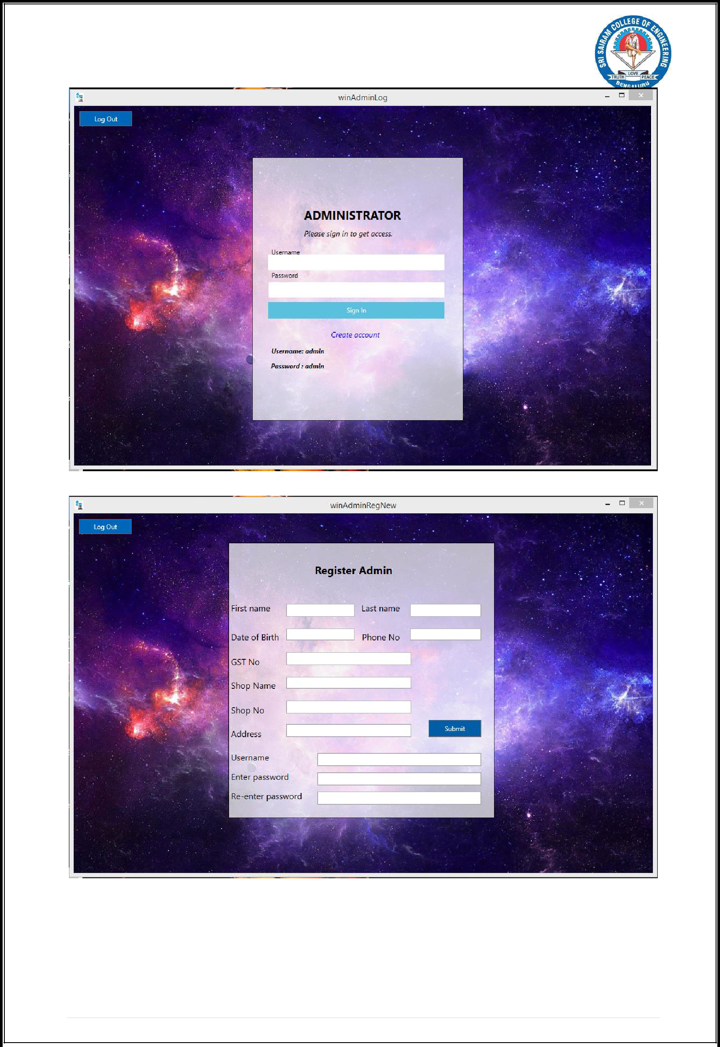

35 | P a g e

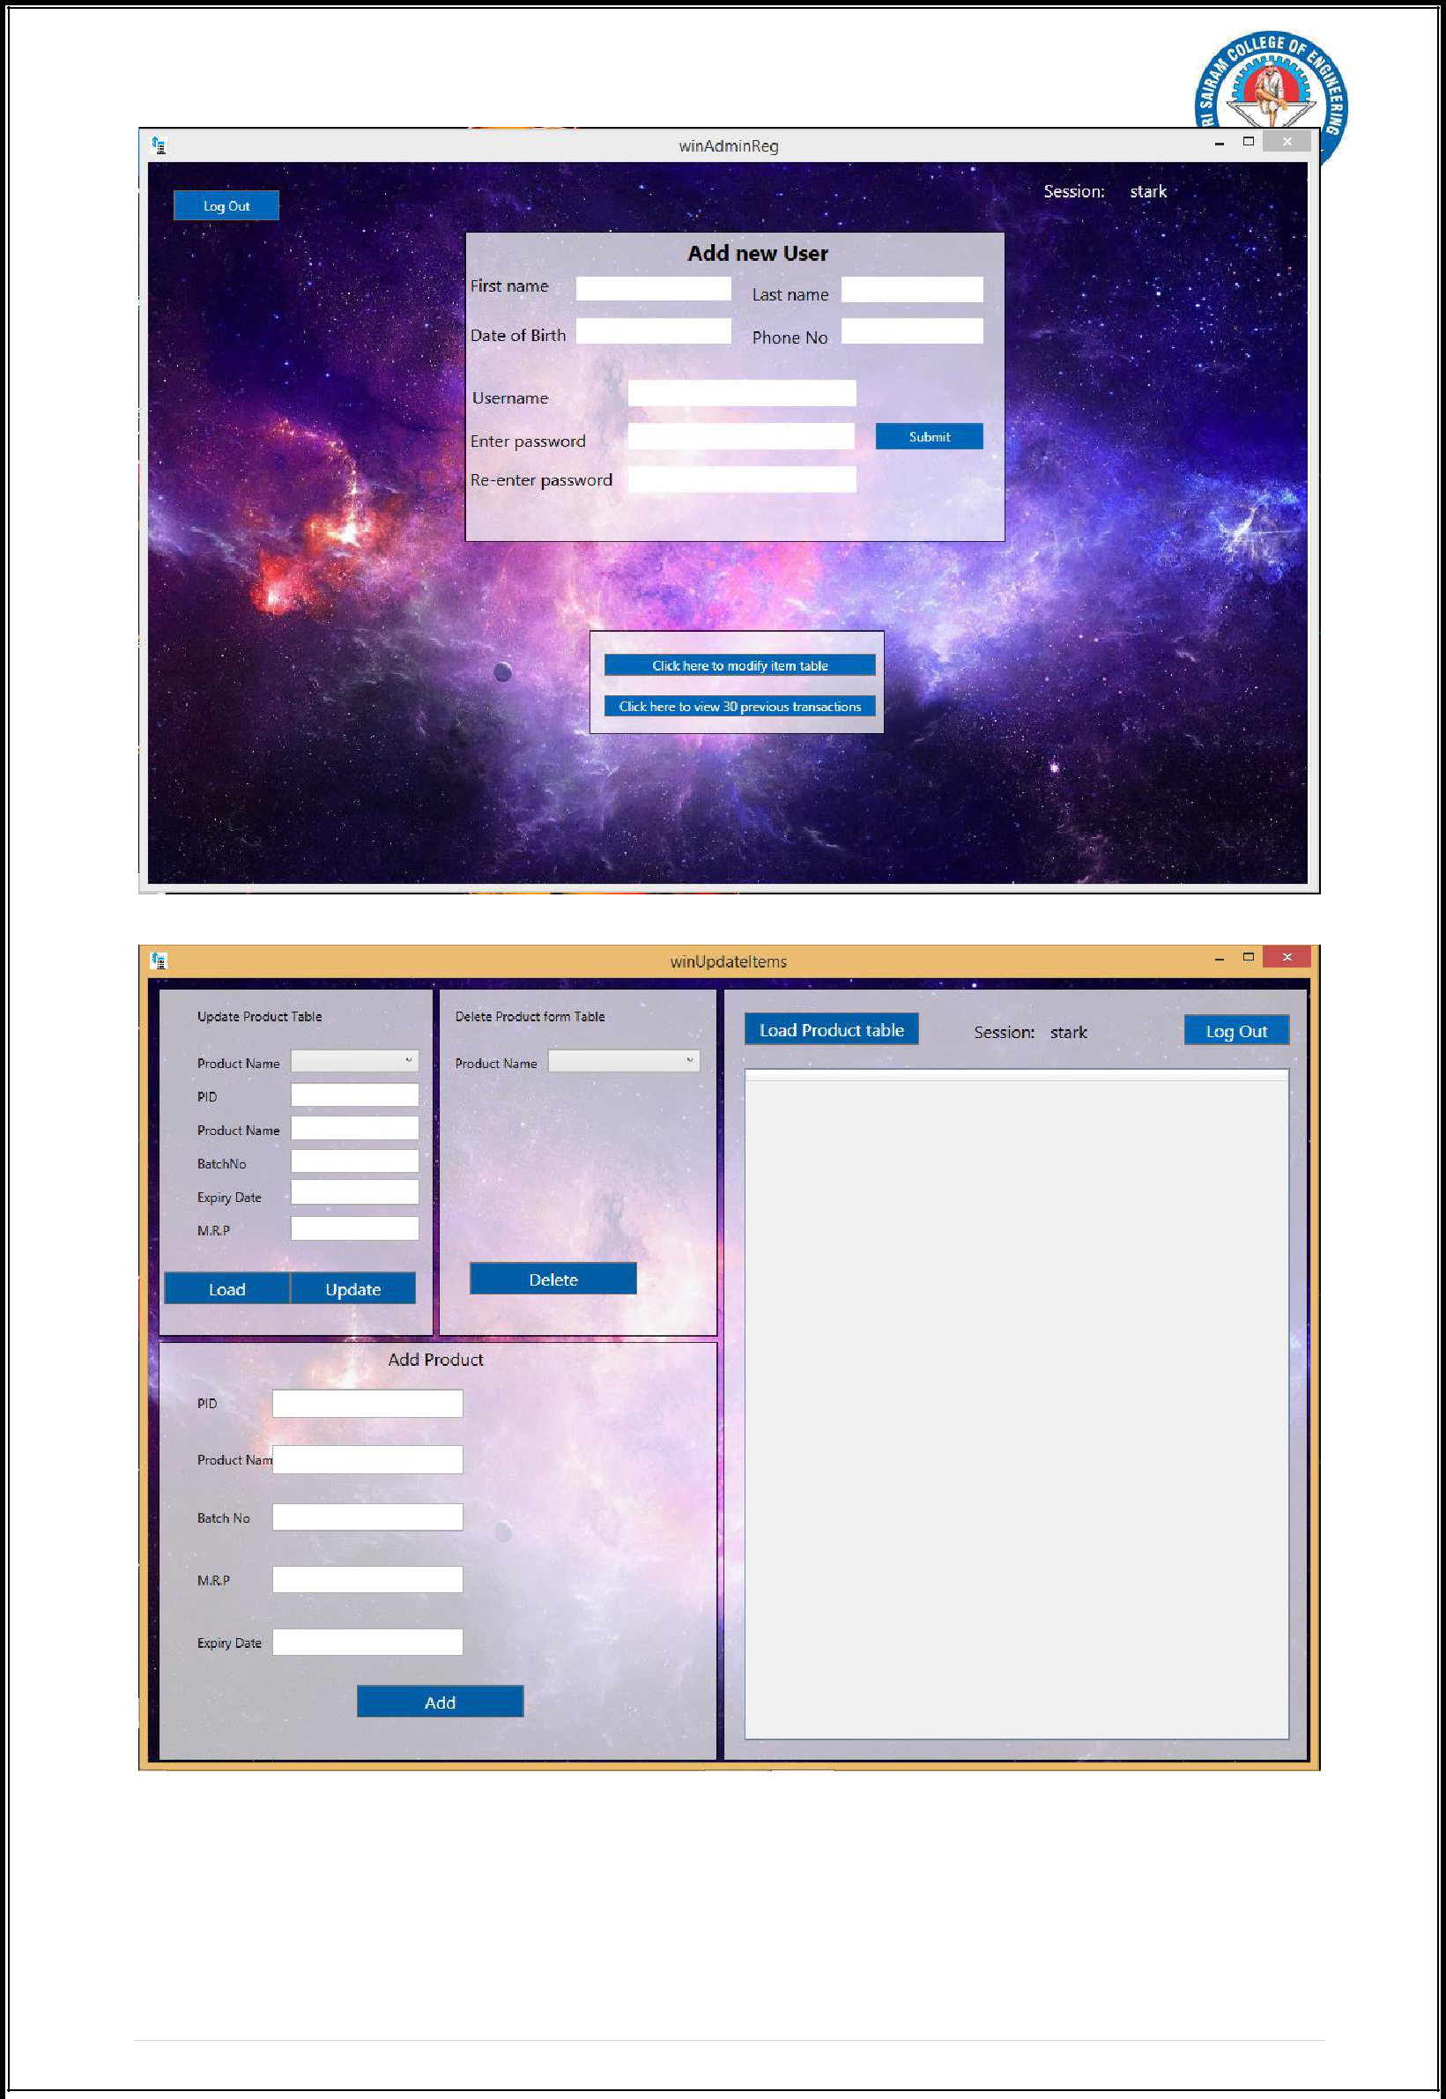

36 | P a g e



1. **CONCLUSION**

It has been a great pleasure for me to work on this exciting and challenging project. This project proved good for me as it provided practical knowledge of not only programming in C#.NET and no some extent Windows Application and SQL Server, but also about all handling procedure related with **“MEDICAL BILLING SYSTEM”**. It also provides knowledge about the latest technology used in developing stand alone application and client server technology that will be great demand in future. This will provide better opportunities and guidance in future in developing projects independently. This project offers user to enter the data through simple and interactive forms. This is very helpful for the client to enter the desired information through so much simplicity.The user is mainly more concerned about the validity of the data, whatever he is entering. There are checks on every stages of any new creation, data entry or updation so that the user cannot enter the invalid data, which can create problems at later date. Sometimes the user finds in the later stages of using project that he needs to update some of the information that he entered earlier. There are options for him by which he can update the records. Moreover there is restriction for his that he cannot change the primary data field. This keeps the validity of the data to longer extent. User is provided the option of monitoring the records he entered earlier. He can see the desired records with the variety of options provided by him. From every part of the project the user is provided with the links through framing so that he can go from one option of the project to other as per the requirement. This is bound to be simple and very friendly as per the user is concerned. That is, we can say that the project is user friendly which is one of the primary concerns of any good project. Data storage and retrieval will become faster and easier to maintain because data is stored in a systematic manner and in a single database.



37 | P a g e



1. **BIBLIOGRAPHY**

**REFERENCE BOOKS:**

1. **Fundamentals of Database Systems, Ramez Elmasri and Shamkant B. Navathe, 7th Edition, 2017, Pearson.**
2. **Database management systems, Ramakrishnan, and Gehrke, 3rd Edition, 2014,McGraw Hill.**
3. **Silberschatz Korth and Sudharshan, Database System Concepts, 6th Edition, Mc- GrawHill, 2013.**
4. **Coronel, Morris, and Rob, Database Principles Fundamentals of Design,**

**Implementation and Management, Cengage Learning 2012.**

**WEB URL’S:**

[http://msdn.microsoft.com](http://msdn.microsoft.com/)

[http://codeproject.com](http://codeproject.com/)

[http://stackoverflow.com](http://stackoverflow.com/)

[http://geeksforgeeks.com](http://geeksforgeeks.com/)



38 | P a g e



39 | P a g e